**SWJTU-OSU 2024-2025(1)**

**Midterm Exam for Air pollution Control Engineering**

**Reference Answer**

**Part I**

**Gap-Fillings** (20points**)**

1. PM2.5 PM10、Pb
2. Liquid
3. Volatile Organic Compounds（有无s不扣分）
4. stratosphere troposphere（顺序写反不扣分）
5. CH4  N2O
6. SO3
7. motor vehicle emissions and fuel combustion (合理即可）
8. Clean Air Act （Amendments）
9. Fuel NOx Thermal NOx Transient NOx（Prompt NOx)

(写的机制也可）

1. Incineration temperature retention time（合理即可）
2. The type of desulfurizer dry or waterish state

（Throwaway Processes、Regenerative Processes）

1. Absorption method Adsorption method

（Activated Carbon、Copper oxide Adsorption只得一分）

**Part II**



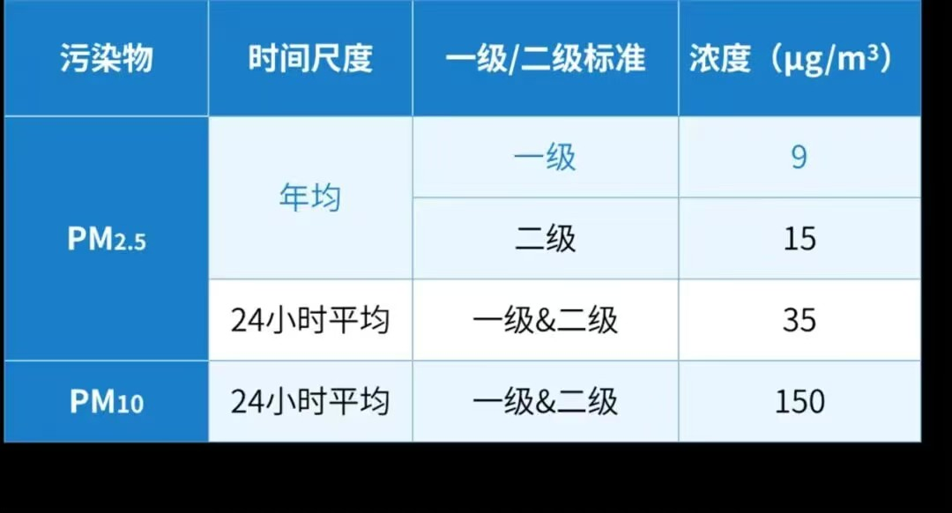

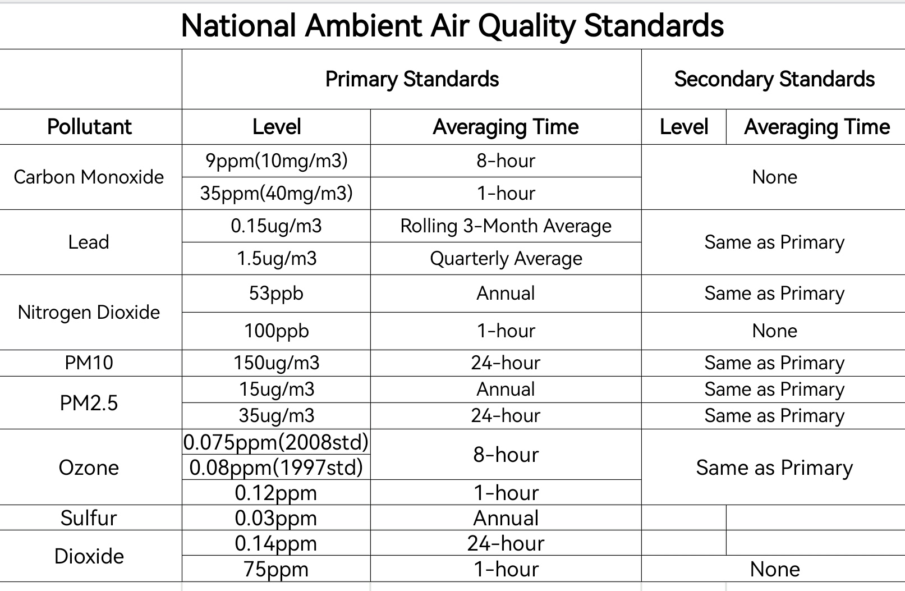

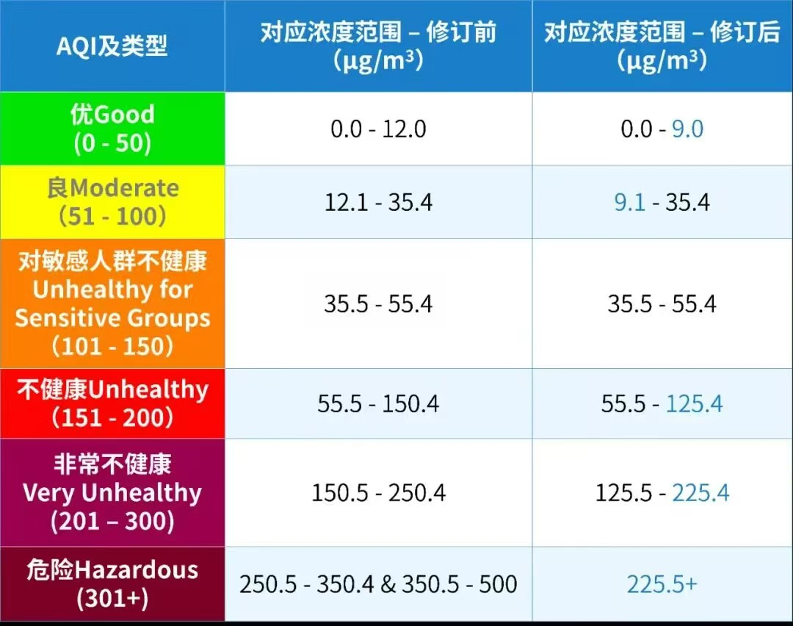

1. 略
2. （不能照抄书上原文一大段，自己概括总结）The Selective Catalytic Reduction (SCR) technology effectuates the conversion of NOx into nitrogen (N2) and water (H2O) by introducing a reductant, typically ammonia or urea, into the flue gas stream in the presence of a catalyst. This process generally achieves a conversion rate of up to 90% at 200 ° C to 400 ° C.

The Selective Non-Catalytic Reduction (SNCR) technology obviates the need for a catalyst. By introducing a reductant, commonly ammonia or urea, directly into the high-temperature flue gas, typically within the range of 850 to 1100 degrees Celsius, it leverages the thermal energy of the flue gas to facilitate the reaction between NOx and the reductant, yielding nitrogen and water as by-products. However, its efficacy is relatively low, commonly ranging between 30% and 70%.（定义、温度差异、效率差异）

1. （不能照抄书上原文一大段，自己概括总结）Absorption method is the use of low volatile or non-volatile solvent to absorb VOCs, and then separate VOCs molecules and the difference in the physical properties of the absorber. The absorption effect mainly depends on the absorption performance of the absorber and the structural characteristics of the absorption equipment. The main application scenarios of adsorption equipment are in the fields of air purification and oil-water separation. For example, painting workshops, electroplating workshops and other places need to purify the air.

The adsorption method is to contact the gaseous mixture containing VOCs with a porous solid, and use the unbalanced molecular attraction or chemical bond force existing on the solid surface to adsorb the VOCs components in the mixed gas on the solid surface. According to the different absorption mechanism, absorption can be divided into physical absorption and chemical absorption two ways. For example, in chemical production, absorption devices can be used to separate and recover metal ions from solutions.（定义、区别、应用）

**Part III** (40points)

1. ①15ppm CO

查表：IH=200 IL=150 CH=15.4 CL=12.4

IAQI(CO)



② PM 10=200ug/m3

查表：IH=150 IL=100 CH=254 CL=154

IAQI(PM10)



③ SO2 =0.15ppm

查表：IH=150 IL=100 CH=0.244 CL=0.144

IAQI(SO2)



IAQImax=IAQI(CO)=193.33 （三个污染物都要计算）

1. 略
2. Total plate area:



The area of each plate: As=6.096m×3.048m=18.580608m2

Double-sided dust collection area: AP=2×AS=37.181216m2

∵A=Ap(N-Ns)

∴（PPT原题）

1. For flour,the filtering veloaty V=2.5 ft/min=0.0127 m/s (Table 6.1)

The area of fabric needed is A=（这里除以3600，自己看单位换算，PPT上除以60是老师编辑错误，但答案正确）

The number of compaterments N=3 (PPT table 6.4,Textbook Table 6.3 )

To meet the design fitering velocity when fitering with one comparterment off-line,there must be 371.655m2 of fabric in each compartment,for 743.31 m2 total.

The fabric area of one bag is （这里用圆柱体侧面积公式，不是体积公式！）

Total number of bags 

Number of bags per room 

In conclusion.

The number of compartments=3,

the filtering velocity: V=0.0127m/s,

the cloth area per compartment =128×2.92m2=373.76m2,

the total number of bags =128×3=384（PPT原题）